A000-Afr-D R Congo-Mbuti Bark Cloth-Forest Gathering Locations-Black Ink on Bleached Bark Cloth- Early 20th c

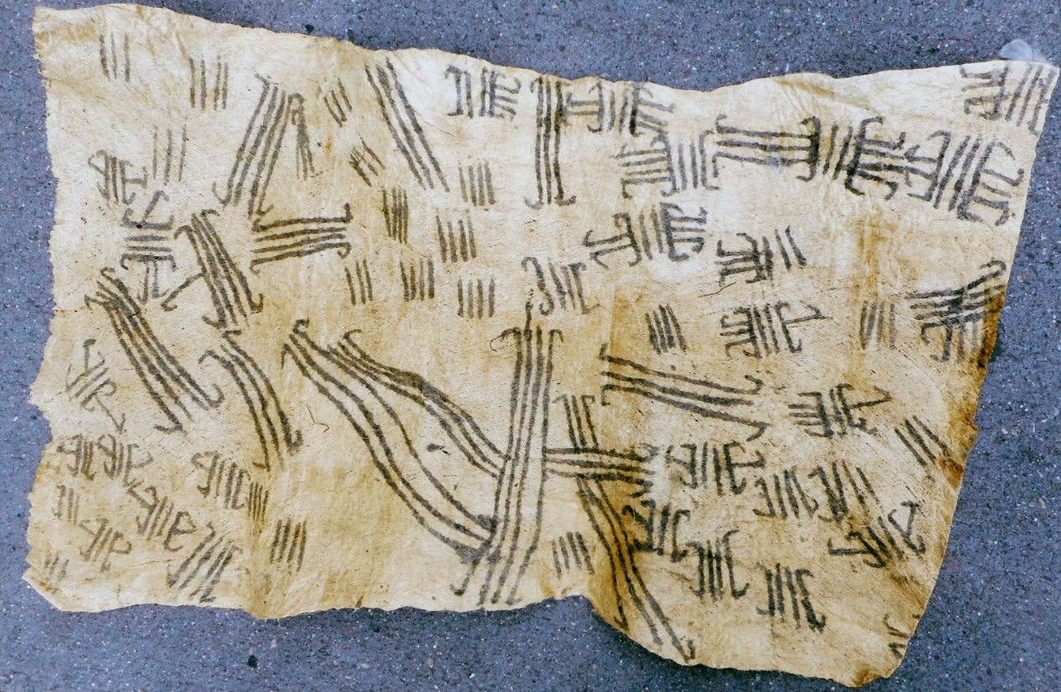

Fig. 1. Afr-D R Congo-Mbuti Bark Cloth-Forest Gathering Locations-Black Ink on Bleached Bark Cloth-Early 20th c

**Case No.: 6**

**Accession No.**

**Formal Label:** Afr-D R Congo-Mbuti Bark Cloth-Forest Gathering Locations-Black Ink on Bleached Bark Cloth-Early 20th c

**Display Description:**

The decipherment of Mbuti Bark Cloth designs has a turbulent history. However, the hypothesis put forth here, that the five-line designs indicated here were actually the trails one Mbuti family has made to acquire the best Food gathering locations. This interpretation was developed in conjunction with a Mbuti male informant.

**LC Classification:**

**Date or Time Horizon:** Early 20th c

**Geographical Area:**

**Map:**

**GPS coordinates:**

**Cultural Affiliation:**

**Media:** bark cloth and black charcoal ink

**Dimensions:**

**Weight:**

**Condition:**

**Provenance:**

**Discussion:**

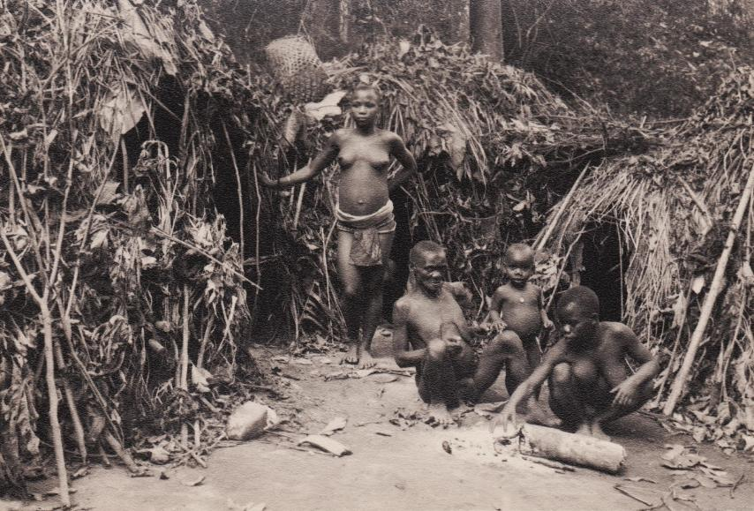

Photograph of Mbuti and male informant in a typical dense forest encampment.